Dear missions’ friends!

This year is very special to us as we are celebrating 10 years of Focus Business School! We intend to commemorate this with a gathering on November 20th at Citykyrkan in Stockholm at 6pm. It’s going to be an amazing evening!
We’ll be telling the story of how it all began in a tiny office in Yangon, Myanmar, and then grew to the ministry that we can see today.
Also, we’ll be joined by:
- Lennart Eriksson, co-founder of Star of Hope
- Mats Tunehag, chairman of Business As Mission
- Torbjörn Ehrling, head of the Swedish chapter of the International Christian Chamber of Commerce.
The evening will feature a debate on how Christian entrepreneurship can have a positive impact on society and lift individuals out of poverty and despair. In addition, there will be music and cake – a night you don’t want to miss in other words!
Register here:
http://focusbusinessschool.org/jubileum/

Here is a short report by Per-Olof Eurell, who has visited the city of Perm, by the foothills of the Ural Mountains in Russia:

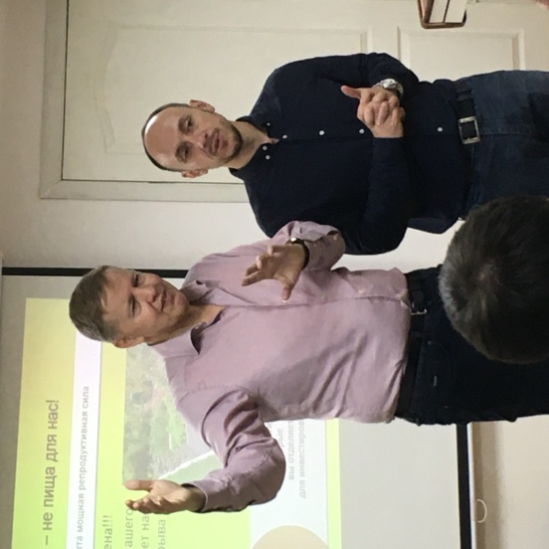
”During the last weekend in October I had the privilege of holding a Saturday seminar for pastors and business people in the city. We also had pastors come from other cities such as the 2-million strong Jekaterinburg. It was a well-prepared seminar and participants expressed an interest in also setting up a Training of Trainers soon in Perm in order to start a local FBS there. The chairman of the Christian Council of Perm wanted a similar intro seminar to be held there as well. Promising!
The open door for Focus Business School in the Ural Mountains came about thanks to Trosgnistan and Tord Renkel. Tord was a missionary in Burma at the same time as Marco Strömberg received the vision for FBS there. He had been living for several years in Russia and done excellent missionary work for Trosgnistan. I travelled together with Tord which was incredibly inspiring! The testimony of how God had healed him of AIDS and how he worked in countries like North Korea and Cuba made an impression on me. A true hero of the faith!
Focus Business School managed to gain a foothold in Russia early on through Word of Life, but Russia of course is a huge country! The work is nowhere near finished. I believe that we will see several new schools started during 2020.”
Per-Olof Eurell
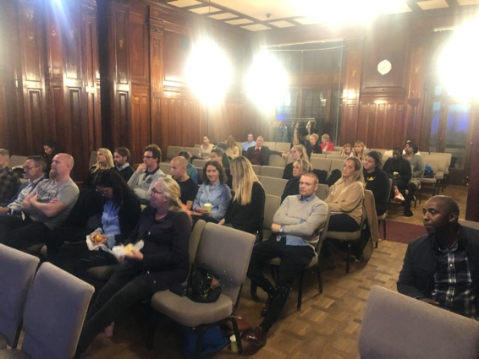
- In the middle of October we started two schools in Stockholm, one in Citykyrkan in English (top picture) and one at Arken in Swedish (bottom picture). We have a nice group of 50 people taking part.
- Our work in Brazil is growing and we’re seeing close to 400 students in the different schools that have been started.
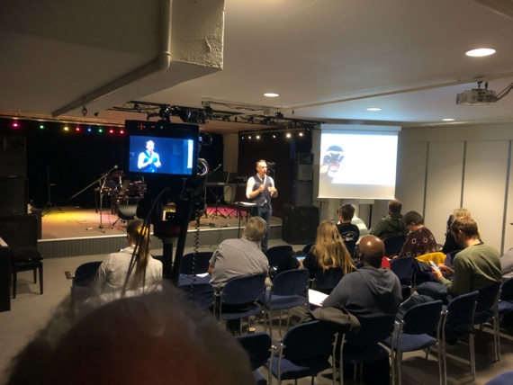
- This spring we will have two trips for business people. One will go to Rwanda and the other to Sri Lanka. The participants will have the opportunity to see what FBS is doing, to take part in seminars and develop their own businesses as well as have time for rest and recreation. If you’d like to take part please drop Marco a line on marco@focusbusinessschool.org.
- Our hope is to be able to send out two missionary couples through FBS to Asia next year. Please pray for the ability to raise up many couples in Sweden who will go out as missionaries to help churches and regions lift their economies.

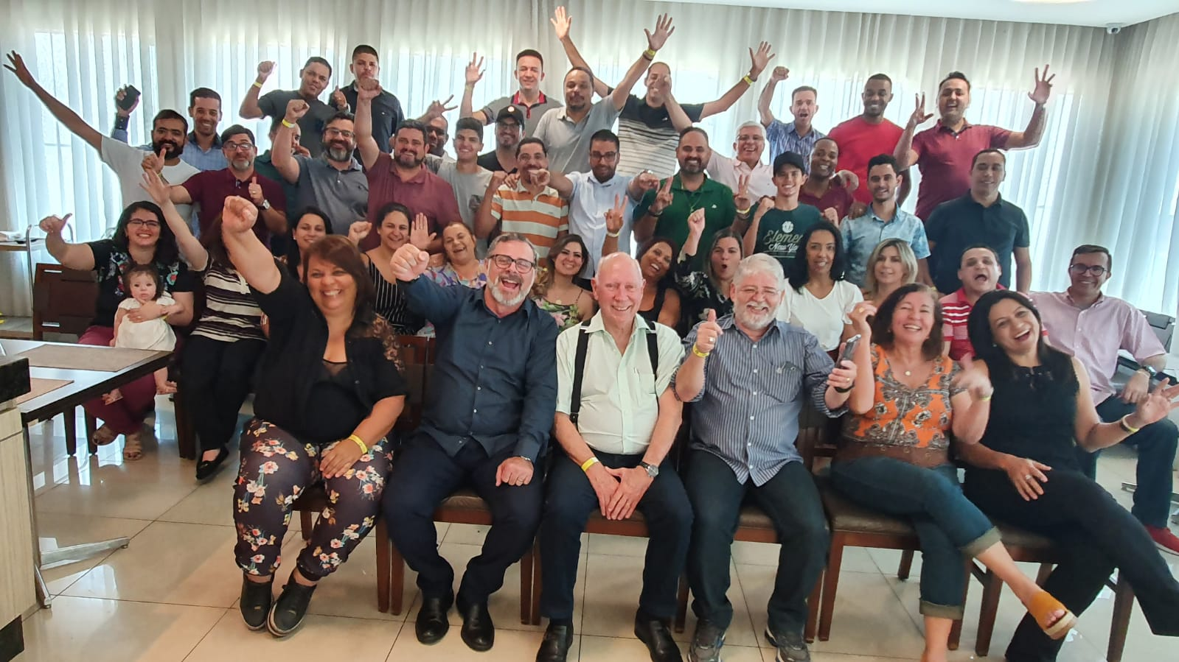
FBS in Brazil

All God’s blessings!

Marco och Anna Strömberg

